**VISVESVARAYA TECHNOLOGICAL UNIVERSITY**

**JnanaSangama, Belagavi – 590018**



An Entrepreneurial Project Report

On

**Open crust mining detection using Satellite Imagery**

Submitted in partial fulfillment of the requirements as a part of the curriculum,

**Bachelors of Engineering in Artificial Intelligence and Machine Learning**

***Submitted by***

**CHAITANYA KARTIK**

**1CR23AI021**

**K. VENKATESWARLU REDDY**

**1CR23AI048**

**TEJASWI YADAV**

**1CR23AI025**

***Under the Guidance of***

**MANIMALA**

**PROFESSOR**

**Department of Artificial Intelligence and Machine Learning**

**Department of Artificial Intelligence and Machine Learning**



**Department of Artificial Intelligence and Machine Learning**

**CMR INSTITUTE OF TECHNOLOGY**

**132, AECS Layout, Kundalahalli, ITPL Main Rd, Bengaluru – 560037**

**2024-25**

**CMR INSTITUTE OF TECHNOLOGY**

**132, AECS Layout, Kundalahalli colony, ITPL Main Rd, Bengaluru-560037**

**Department of Artificial Intelligence and Machine Learning **

**CERTIFICATE**

Certified that the Entrepreneurial Project entitled **Open crust mining detection using Satellite Imagery** is presented by **Mr. Chaitanya Kartik,** bonafide student of **CMR Institute of Technology** in partial fulfillment of the requirements as a part of the curriculum, **Bachelors of Engineering in Artificial Intelligence and Machine Learning,** of **Visvesvaraya Technological University, Belagavi** during the year **2024-25**. It is certified that all correction/suggestion indicated for Internal Assessment have been incorporated in the report deposited in the departmental library. The Entrepreneurial Project report has been approved as it satisfies the academic requirements in respect of the Technical Seminar prescribed for the bachelor of engineering degree.

**(Ms. Guide Name ) (Dr. Shyam P Joy)**

**Signature of the Guide Signature of the HOD**

Letter from Agency with project requirements

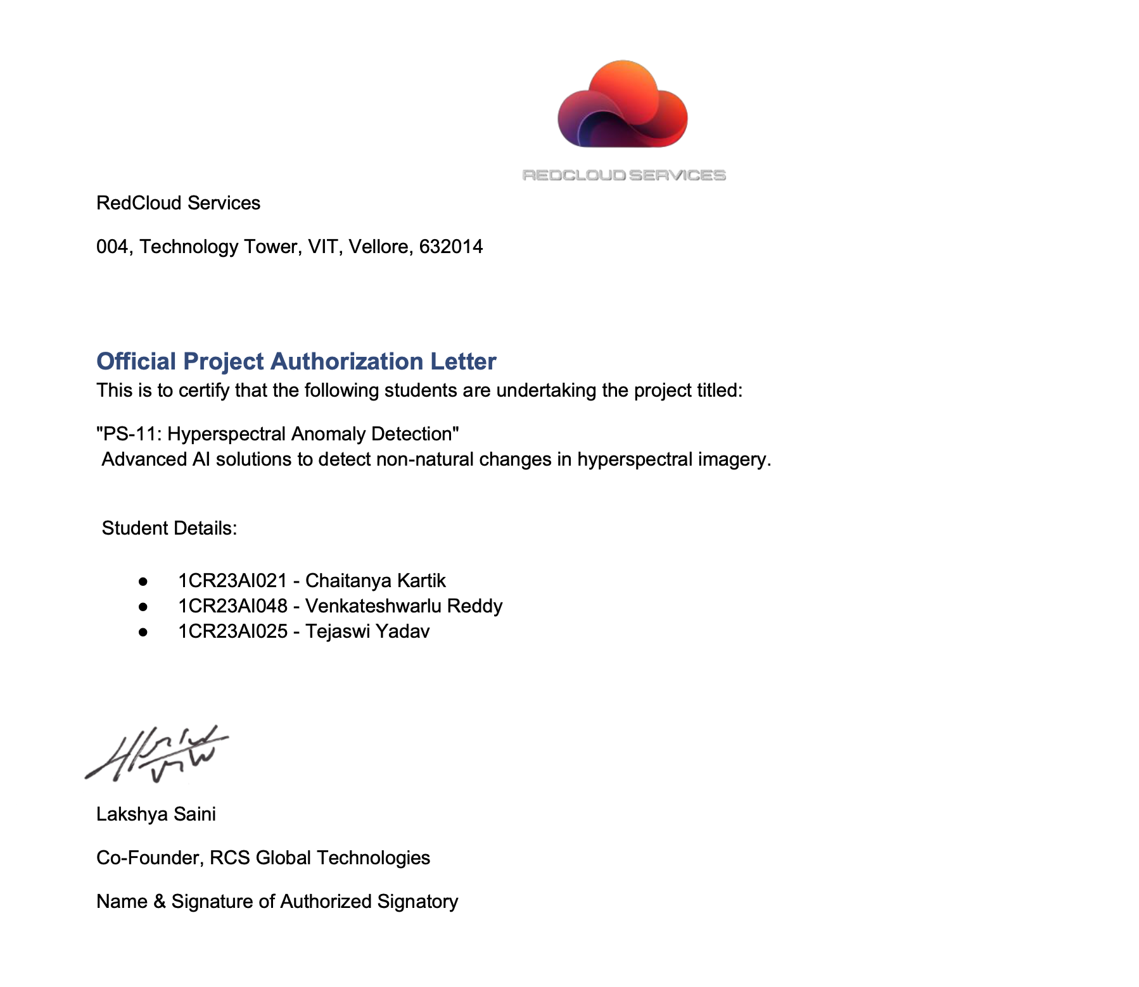

ORENEXUS:

MINING SMARTER – MAPPING IMPACT, VALUE, AND COMPLIANCE GAPS

## ABSTRACT

This project report examines the development of OreNexus, an automated mining activity monitoring system that combines satellite imagery analysis, geospatial data processing, and AI/ML techniques to detect, monitor, and report on open-crust mining operations. The system focuses on compliance monitoring, environmental impact assessment, and volumetric analysis of mining sites. OreNexus leverages Sentinel-1 SAR and Sentinel-2 multispectral imagery from Copernicus, along with digital elevation models, to provide comprehensive analysis of mining activities. The proof of concept demonstrates successful ground disturbance detection, vegetation monitoring, and change detection capabilities using the Korba Coal Mining Area in Chhattisgarh as a test case. The system addresses critical challenges in mining oversight including illegal operations, environmental degradation, and revenue loss for governing bodies through automated detection and reporting mechanisms.

## 

## ACKNOWLEDGEMENT

It is my proud privilege and duty to acknowledge the kind of help and guidance received from several people in preparation of this report. Apart from my own, the success of this report depends largely on the encouragement and guidelines of many others. It would have not been possible to prepare this report in this form without their valuable help, co-operation and guidance.

I would like to express my deep sense of gratitude to our Principal for his motivation and for creating an inspiring atmosphere in college by providing state of the art facilities for preparation and delivery of this report.

My sincere thanks to Head of Department for his whole-hearted support in completion of the project.

I am highly indebted to my project guide for guiding and giving timely advices and suggestions in the successful completion of this project.

My sincere thanks to project coordinator for having supported the work related to this project.

Last but not least, I would like to put forward my heartfelt acknowledgement to all my classmates, friends and all those who have directly or indirectly provided their overwhelming support during my project work and the development of this report.

| **Section** | **Title** | **Page** |
| --- | --- | --- |
|  | Certificate | II |
|  | Title Page | III |
|  | Abstract | IV |
|  | Acknowledgement | V |
| CHAPTER 1. | Introduction |  |
| 1.1 | OreNexus Overview | 1 |
| 1.2 | Problem Statement | 2 |
| 1.3 | Satellite Data Sources | 3 |
| 1.4 | Current Status | 4 |
| CHAPTER 2. | Review of Related Literature |  |
| 2.1 | Literature Review | 6 |
| 2.2 | Problem Statement | 7 |
| CHAPTER 3. | Design and Implementation |  |
| 3.1 | Data Infrastructure | 8 |
| 3.2 | Frontend Web Application | 9 |
| 3.3 | Data Processing Pipeline | 10 |
| 3.4 | Sentinel-1 SAR Analysis | 11 |
| 3.5 | Sentinel-2 Optical Analysis | 13 |
| 3.6 | Cross-Sensor Fusion | 15 |
| 3.7 | Report Generation System | 16 |
| CHAPTER 4. | Testing/Result and Analysis |  |
| 4.1 | Test Data Coverage | 17 |
| 4.2 | Analysis Results | 18 |
| CHAPTER 5. | Conclusion | 19 |
| CHAPTER 6. | References | 20 |

| **Figure Number** | **Description** |
| --- | --- |
| Fig 1.1 | Sentinel-1 SAR Data Coverage |
| Fig 1.2 | Sentinel-2 Optical Imagery |
| Fig 3.1 | OreNexus System Architecture |
| Fig 3.2 | Data Processing Pipeline |
| Fig 3.3 | Web Interface Layout |

## CHAPTER 1

### INTRODUCTION

#### 1.1. ORENEXUS OVERVIEW

OreNexus is an automated mining activity monitoring system that combines satellite imagery analysis, geospatial data processing, and AI/ML techniques to detect, monitor, and report on open-crust mining operations. The system focuses on compliance monitoring, environmental impact assessment, and volumetric analysis of mining sites.

In 1997, satellite-based monitoring of mining activities began with basic optical imagery analysis. Since then, the capability to monitor mining operations has evolved significantly with the introduction of synthetic aperture radar and multispectral imaging systems.OreNexus addresses these challenges by providing an automated system to delineate mining areas, identify illegal operations, calculate extraction volumes, and visualize data for effective decision-making. The system combines radar-based ground disturbance detection with optical vegetation monitoring to provide comprehensive analysis of mining site changes over time.

Fig 1.1 Sentinel-1 SAR Data Coverage

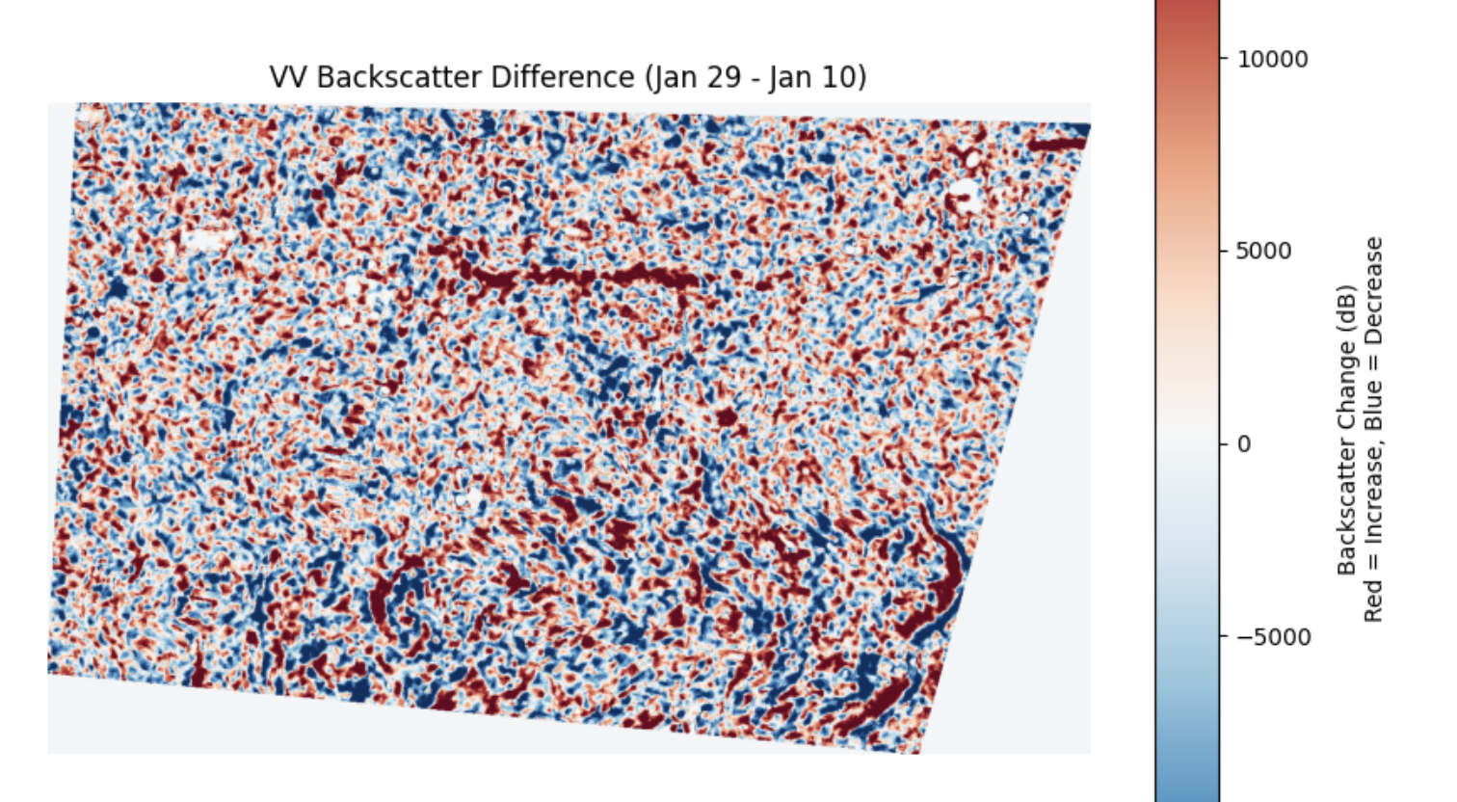

#### 1.2. PROBLEM STATEMENT

There are approximately 247 million vehicles globally powered by fossil fuels extracted through mining operations. The mining industry faces significant challenges in monitoring and compliance. Traditional methods rely on periodic ground surveys and manual inspection of satellite imagery, which are time-consuming, expensive, and often delayed.

* Manual satellite data download and processing requirements
* Inability to detect unauthorized mining expansion in real-time
* Lack of automated systems for volumetric analysis
* Difficulty in assessing environmental impact across large areas
* No standardized reporting mechanism for different stakeholders
* Limited temporal coverage due to manual processing bottlenecks

Current mining monitoring approaches lack the automation and integration necessary for effective oversight. Government authorities need compliance-focused reporting, environmental agencies require ecological impact assessments, and mining corporations need operational efficiency metrics. No single system addresses all these requirements simultaneously.

OreNexus proposes to solve these problems through automated satellite data processing, machine learning-based detection, and specialized report generation for different stakeholder groups. The system aims to provide near real-time monitoring capabilities with minimal human intervention.

#### 1.3. SATELLITE DATA SOURCES

OreNexus utilizes multiple satellite data sources to provide comprehensive mining activity analysis:

SENTINEL-1 SAR Sentinel-1 provides synthetic aperture radar imagery that penetrates clouds and operates day and night. The system uses dual-polarization data in VV and VH modes at 10-meter resolution. VV polarization is sensitive to ground roughness changes caused by mining excavation, while VH polarization detects vegetation loss. The radar backscatter is measured in decibels and processed as gamma naught radiometric terrain-corrected products.

SENTINEL-2 MULTISPECTRAL Sentinel-2 provides optical imagery with 13 spectral bands covering visible, near-infrared, and shortwave infrared wavelengths. OreNexus primarily uses Band 04 (Red, 665nm), Band 08 (NIR, 842nm), and Band 11 (SWIR, 1610nm) at 10-20 meter resolution. These bands enable calculation of vegetation indices and bare soil detection. The Level-2A bottom-of-atmosphere reflectance products are used after atmospheric correction.

DIGITAL ELEVATION MODEL Copernicus DEM and SRTM provide 30-meter resolution elevation data for terrain analysis and volumetric calculations. The single-band GeoTIFF format contains elevation values in meters above sea level. DEM data enables 3D visualization and volume estimation for extracted material.

AOI BOUNDARIES Area of Interest boundaries are obtained from Google Earth or government lease documents in KML or GeoJSON format. These vector boundaries define the legal mining area for compliance checking and enable calculation of mining activity occurring inside versus outside authorized zones.

Fig 1.2. Sentinel-2 Optical Imagery

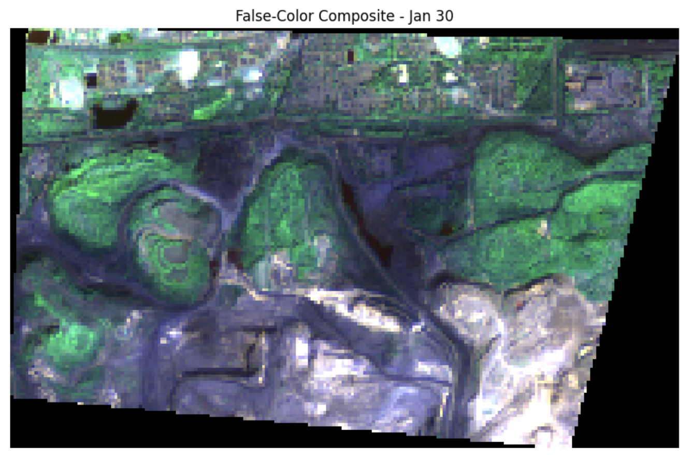

#### 1.4. CURRENT STATUS

OreNexus is currently in the proof of concept phase with several completed components demonstrating core functionality.

COMPLETED COMPONENTS The data infrastructure supports Sentinel-1 SAR, Sentinel-2 multispectral, and DEM data processing. Test data covers the Korba Coal Mining Area in Chhattisgarh for January-February 2023. The frontend web application provides an interactive 2D mapping interface built with Leaflet.js, supporting AOI upload, temporal analysis, and layer control.

Two Jupyter notebooks demonstrate the analysis pipeline. The Sentinel-1 notebook implements speckle noise reduction, VV/VH backscatter temporal differencing, radar vegetation index calculation, and object-based change detection. The Sentinel-2 notebook calculates NDVI and BSI indices, performs temporal change detection, and classifies land cover changes.

A report generation system creates PDF reports with matplotlib visualizations, time-series plots, and compliance summaries. Demo visualizations include synthetic dataset generation for testing multi-site analysis workflows.

TECHNOLOGY STACK The current implementation uses Python 3 with rasterio for geospatial raster processing, geopandas for vector operations, numpy and scipy for numerical computing, matplotlib for visualization, and scikit-image for segmentation. The frontend uses vanilla JavaScript with Leaflet.js for mapping.

LIMITATIONS Current limitations include manual satellite data download from EO Browser, no automated segmentation model, threshold-based detection rather than machine learning, limited AOI coverage, and incomplete 3D visualization. The system requires Jupyter notebook execution rather than automated processing.

## CHAPTER 2 REVIEW OF PROBLEM STATEMENT

#### 2.1. PROBLEM STATEMENT

Mining activity monitoring systems face several critical challenges that limit their effectiveness for compliance and environmental oversight. Manual processing of satellite imagery creates significant delays between data acquisition and actionable intelligence. Government authorities require timely information to enforce mining regulations and prevent unauthorized expansion beyond permitted boundaries.

Environmental impact assessment requires analyzing large geographic areas over extended time periods. Current manual approaches cannot scale to monitor multiple mining sites simultaneously. The lack of automated processing creates gaps in temporal coverage, potentially missing rapid changes in mining activity.

Different stakeholders require specialized reporting formats. Government agencies need compliance-focused reports highlighting boundary violations and regulatory infractions. Environmental organizations require ecological impact assessments including proximity to protected areas and water bodies. Mining corporations need operational efficiency metrics and production estimates. No existing system provides customized reporting for these diverse stakeholder needs.

Volumetric analysis of extracted material requires processing elevation data from multiple time periods. Manual calculation of excavation volumes is time-consuming and prone to errors. Automated volume estimation using DEM differencing has not been widely implemented in operational mining monitoring systems.

The research question addressed by OreNexus is: Can an automated satellite-based monitoring system achieve reliable mining activity detection with minimal human intervention while providing specialized reporting for multiple stakeholder groups? The system must balance detection accuracy, processing speed, and report customization to serve as a practical tool for mining oversight.

## CHAPTER 3 DESIGN AND IMPLEMENTATION

#### 3.1. DATA INFRASTRUCTURE

The data infrastructure forms the foundation of the OreNexus system, managing multiple satellite data types and formats.

SENTINEL-1 SAR DATA Sentinel-1 data is acquired in Ground Range Detected format with dual polarization. The product type is IW (Interferometric Wide Swath) mode processed to decibel gamma naught radiometric terrain-corrected format. Files are stored as GeoTIFF with separate files for VV and VH polarizations. The naming convention includes acquisition date, satellite designation, polarization mode, and processing level.

Data is organized by location and acquisition date in the directory structure. The Korba Coal AOI contains three temporal snapshots from January 10, January 29, and February 27, 2023. Each date folder contains VV and VH polarization files covering the same spatial extent.

SENTINEL-2 MULTISPECTRAL DATA Sentinel-2 Level-2A data provides bottom-of-atmosphere reflectance after atmospheric correction. Individual spectral bands are stored as separate GeoTIFF files. Band 04 (Red), Band 08 (NIR), and Band 11 (SWIR) are the primary bands used for analysis. Raw pixel values require division by 10000 to convert to reflectance values in the 0-1 range.

Temporal snapshots for January 10 and January 30, 2023 enable change detection over a 20-day period. RGB composite images are also stored for visual interpretation and validation of analysis results.

DIGITAL ELEVATION DATA Copernicus DEM data at 30-meter resolution covers the Korba Coal AOI. Single-band GeoTIFF files contain elevation values in meters. The DEM enables terrain analysis, 3D visualization, and future implementation of volumetric calculations through DEM differencing.

AOI BOUNDARY FILES Google Earth KML files define the legal mining boundaries. Conversion scripts transform KML to GeoJSON format for use in web mapping applications. The vector boundaries enable spatial queries to determine if detected mining activity falls within or outside authorized areas.

#### 3.2. FRONTEND WEB APPLICATION

The frontend web application provides an interactive interface for visualizing satellite data and analysis results.

ARCHITECTURE The application uses a modular architecture with separation of concerns. CSS modules include base styles, component styles, layout definitions, and theme variables. JavaScript modules are organized into config, core functionality, data management, UI modules, and utility functions.

MAPPING INTERFACE Leaflet.js provides the 2D mapping foundation with OpenStreetMap base layers. The map supports panning, zooming, and layer control. Users can upload AOI boundaries in KML or GeoJSON format, which are parsed and displayed as polygon overlays.

TEMPORAL ANALYSIS A date picker allows selection of baseline and analysis dates for change detection. The system loads corresponding satellite imagery and displays change detection results as colored overlays. Red areas indicate detected mining activity, while green areas show vegetation regrowth.

LAYER CONTROL Users can toggle visibility of different data layers including Sentinel-1 VV and VH backscatter, Sentinel-2 band composites, NDVI and BSI index maps, change detection results, and AOI boundaries. The layer control panel provides checkboxes for each layer with opacity sliders.

MINING SITE MANAGEMENT A side panel lists multiple mining sites with status indicators. Users can select sites to view their analysis results and reports. The panel displays basic statistics including area, detected changes, and compliance status.

3D VIEWER A separate 3D viewer page is under development using terrain visualization libraries. The viewer will display DEM data with color-coded elevation and overlay mining activity detection results. Users will be able to rotate and zoom the 3D terrain model.

Fig 3.1. OreNexus System Architecture

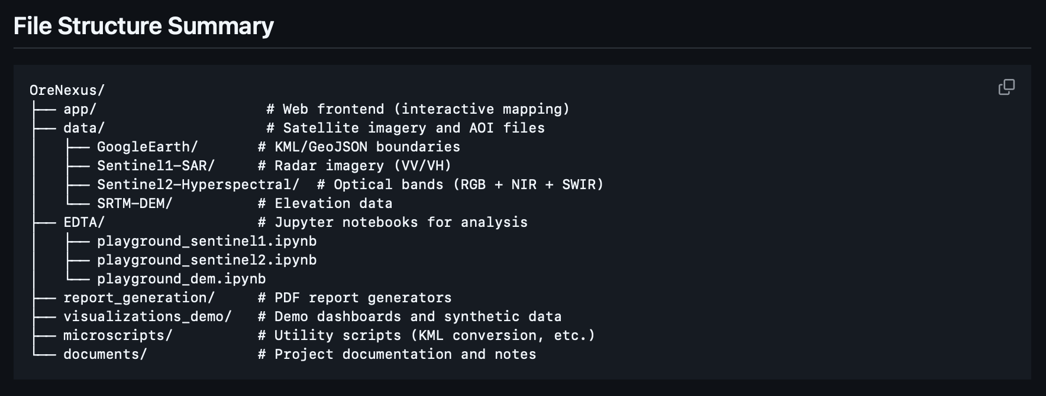

Fig 3.2. Data Processing Pipeline

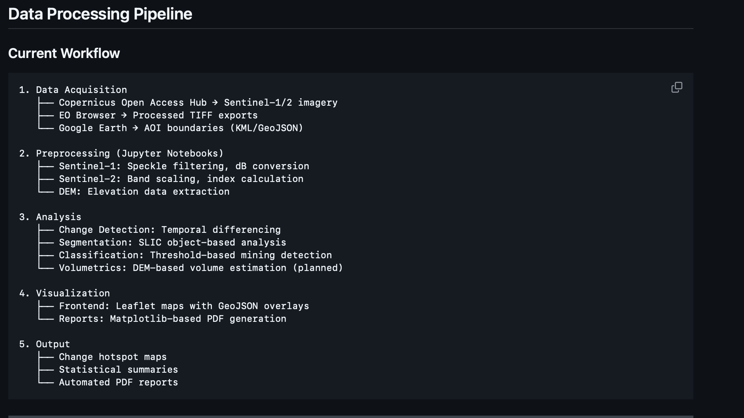

#### 

#### 3.3. DATA PROCESSING PIPELINE

The data processing pipeline transforms raw satellite imagery into actionable mining activity information through multiple stages.

STAGE 1: DATA ACQUISITION Satellite imagery is currently downloaded manually from the Copernicus EO Browser. Users navigate to the EO Browser website, select the data source (Sentinel-1 or Sentinel-2), draw the AOI or upload a KML file, set the date range, and export individual bands as GeoTIFF files. For Sentinel-1, VV and VH decibel gamma naught layers are exported. For Sentinel-2, bands B04, B08, and B11 are exported individually.

STAGE 2: PREPROCESSING GeoTIFF files are loaded using the rasterio library in Python. Sentinel-1 data is already in decibel format but requires speckle noise reduction using median filtering with 5x5 or 7x7 kernels. Sentinel-2 data requires scaling by dividing pixel values by 10000 to obtain reflectance values. Invalid pixels with values of 0 or 65535 are set to NaN.

STAGE 3: INDEX CALCULATION For Sentinel-2 data, vegetation and soil indices are calculated. NDVI is computed as (NIR - Red) / (NIR + Red). BSI is approximated as (SWIR + Red - NIR) / (SWIR + Red + NIR). For Sentinel-1 data, the Radar Vegetation Index can be calculated from VV and VH polarizations.

STAGE 4: TEMPORAL DIFFERENCING Change detection requires loading data from two time periods. For each parameter (VV, VH, NDVI, BSI), the difference is calculated as later date minus earlier date. Scene-wide normalization removes atmospheric effects by subtracting the mean difference value.

STAGE 5: THRESHOLD APPLICATION Thresholds are applied to identify significant changes. For Sentinel-1, VV increases greater than 4 dB indicate ground disturbance. VH decreases less than -3 dB indicate vegetation loss. For Sentinel-2, BSI increases greater than 0.2 indicate new mining activity. NDVI decreases confirm vegetation loss.

STAGE 6: SEGMENTATION Object-based analysis uses SLIC segmentation to group pixels into approximately 5000 superpixels. Per-segment statistics are calculated including mean VV, VH, NDVI, and BSI. Segments are classified based on combined criteria from multiple sensors.

STAGE 7: VISUALIZATION AND EXPORT Results are visualized as colored overlays on base maps. Change detection maps use red for mining activity and green for vegetation regrowth. Hotspot coordinates and area statistics are exported as CSV files. GeoTIFF files containing classified results are saved for use in the web interface.

#### 3.4. SENTINEL-1 SAR ANALYSIS

Sentinel-1 synthetic aperture radar analysis forms a core component of ground disturbance detection.

SPECKLE NOISE REDUCTION SAR imagery contains speckle noise due to coherent interference of radar returns. Median filtering with a 5x5 kernel effectively reduces speckle while preserving edge features. The scipy.ndimage.median_filter function is applied to both VV and VH polarization data. Larger kernel sizes of 7x7 provide stronger noise reduction at the cost of spatial resolution.

VV BACKSCATTER ANALYSIS VV polarization measures vertical transmit and vertical receive radar returns. This configuration is sensitive to surface roughness changes. Mining excavation exposes rough surfaces of broken rock and disturbed soil, increasing backscatter. The temporal difference in VV backscatter is calculated by subtracting the baseline date from the analysis date. Positive differences indicate increased roughness.

Threshold values of 4 to 9 dB increase are used to identify mining activity. Lower thresholds detect more subtle changes but increase false positives. Higher thresholds provide high confidence detection but may miss smaller disturbances. A threshold of 6 dB provides balanced detection performance for the Korba Coal test site.

VH BACKSCATTER ANALYSIS VH polarization measures vertical transmit and horizontal receive radar returns. This cross-polarization configuration is sensitive to vegetation structure. Healthy vegetation causes depolarization, producing strong VH returns. Vegetation removal reduces VH backscatter.

Temporal differencing identifies areas where VH decreased significantly. Threshold values of -3 to -8 dB decrease indicate vegetation loss. The combination of VV increase and VH decrease provides high confidence detection of mining-related land cover change.

COMBINED DETECTION High confidence mining hotspots are identified where both VV increases exceed threshold and VH decreases exceed threshold. The boolean intersection of these conditions produces a binary mask of detected mining activity. Area statistics are calculated by counting pixels and multiplying by pixel area in square meters.

NORMALIZATION Scene-wide normalization removes atmospheric and acquisition geometry effects. The mean difference value across the entire scene is calculated and subtracted from all pixels. This normalization focuses detection on local anomalies rather than global trends.

#### 3.5. SENTINEL-2 OPTICAL ANALYSIS

Sentinel-2 multispectral analysis monitors vegetation health and bare soil exposure through spectral indices.

BAND LOADING AND SCALING Individual spectral bands are loaded as separate GeoTIFF files. Band 04 (Red, 665nm) captures chlorophyll absorption. Band 08 (NIR, 842nm) captures vegetation reflectance. Band 11 (SWIR, 1610nm) is sensitive to soil moisture and exposed minerals.

Raw digital numbers are scaled to reflectance by dividing by 10000. This scaling converts the 0-10000 range to physical reflectance values between 0 and 1. Values outside this range or equal to 0 are set to NaN to handle no-data pixels.

NDVI CALCULATION The Normalized Difference Vegetation Index quantifies vegetation greenness and health. The formula is NDVI = (NIR - Red) / (NIR + Red). A small constant of 1e-9 is added to the denominator to avoid division by zero.

NDVI values range from -1 to +1. Water bodies and bare surfaces typically show NDVI less than 0.2. Sparse vegetation produces NDVI between 0.2 and 0.5. Healthy dense vegetation yields NDVI greater than 0.6. Mining sites typically show NDVI less than 0.2 due to removal of vegetation and exposure of mineral surfaces.

BSI CALCULATION The Bare Soil Index quantifies exposed soil and rock surfaces. The approximation formula used is BSI = (SWIR + Red - NIR) / (SWIR + Red + NIR). Higher BSI values indicate more exposed soil or rock.

Mining excavation removes vegetation and soil cover, exposing bedrock and mineral deposits. This increases SWIR and Red reflectance while decreasing NIR reflectance, resulting in higher BSI values. Areas with active mining typically show BSI greater than 0.

TEMPORAL CHANGE DETECTION Temporal differencing compares index values between two dates. NDVI difference is calculated as later date minus earlier date. Negative NDVI differences indicate vegetation loss. BSI difference is calculated similarly. Positive BSI differences indicate increased bare soil exposure.

CLASSIFICATION Pixels are classified into categories based on combined index changes. Mining or clearing is identified where BSI increases by more than 0.2. Vegetation regrowth occurs where NDVI increases by more than 0.15. Stable areas show changes below these thresholds.

The classified change map uses numeric codes: 0 for stable, 1 for mining activity, 2 for vegetation regrowth. This classification enables calculation of area statistics for each change type.

#### 3.6. CROSS-SENSOR FUSION

Combining Sentinel-1 SAR and Sentinel-2 optical data improves detection reliability through multi-sensor agreement.

OBJECT-BASED SEGMENTATION SLIC (Simple Linear Iterative Clustering) segmentation groups pixels into superpixels based on spatial proximity and spectral similarity. The scikit-image library implementation is used with approximately 5000 segments for a typical mining site.

Segmentation is applied to the baseline date imagery. Each pixel is assigned a segment ID. The same segmentation is used for both SAR and optical data to ensure spatial correspondence.

PER-SEGMENT STATISTICS Mean values are calculated for each segment across all relevant parameters: VV backscatter, VH backscatter, NDVI, and BSI. Temporal changes are computed for each segment by differencing the mean values between dates.

Object-based statistics are more robust than pixel-level values because they average out noise and speckle within each segment. Segments represent meaningful ground features rather than arbitrary pixels.

MULTI-SENSOR CRITERIA High confidence mining detection requires agreement across multiple sensors. A segment is classified as mining activity if it meets all of the following criteria: VV increase greater than 4 dB, VH decrease less than -3 dB, and BSI increase greater than 0.2.

This combined approach reduces false positives that might occur from single-sensor analysis. For example, agricultural bare soil might increase BSI but would not show the characteristic VH decrease and VV increase pattern of mining excavation.

SPATIAL COHERENCE Object-based results show improved spatial coherence compared to pixel-based classification. Detected mining areas form contiguous regions rather than scattered pixels. This spatial coherence matches the expected pattern of actual mining operations which occur in continuous excavation areas.

POST-PROCESSING Small isolated segments below a minimum area threshold are removed as likely false positives. Morphological operations can smooth boundaries of detected regions. The final output is a cleaned binary mask of high confidence mining activity.

3.7. REPORT GENERATION SYSTEM

The report generation system creates formatted PDF documents tailored for different stakeholder groups.

REPORT TYPES Environmental reports focus on ecological impact including vegetation loss area, proximity to water bodies and forests, and biodiversity considerations. Economic reports estimate production volumes, calculate operational costs, and project revenue. Government reports emphasize compliance status, boundary violations, and regulatory adherence.

MATPLOTLIB IMPLEMENTATION The current implementation uses matplotlib for chart generation. Figure objects are created with specified dimensions and resolution. Subplots organize multiple charts on each page. Time-series line plots show trends in extraction volume or vegetation cover over time. Bar charts compare metrics across multiple sites. Heatmaps visualize spatial patterns of compliance violations.

DATA PREPARATION Synthetic datasets are generated for testing report generation workflows. Entity master data includes mine locations, ownership information, and operational status. Temporal data contains monthly extraction volumes, workforce counts, and equipment utilization. Compliance flags indicate violations and their severity.

PDF GENERATION The matplotlib savefig function exports figures as PDF pages. Multiple figures are combined into a single PDF document using PDF merging libraries. Text annotations provide context and interpretation of charts. Tables present detailed statistics and compliance metrics.

TEMPLATE SYSTEM Future development will implement a template-based system for report customization. HTML templates will define report structure and styling. Data will be injected into templates through a rendering engine. This approach will enable easier customization for different stakeholder requirements.

AUTOMATION Automated report generation will trigger upon completion of analysis workflows. Reports will be generated for configurable time periods such as weekly, monthly, or quarterly. Email delivery will distribute reports to stakeholders automatically.

Fig 3.3. Web Interface Layout

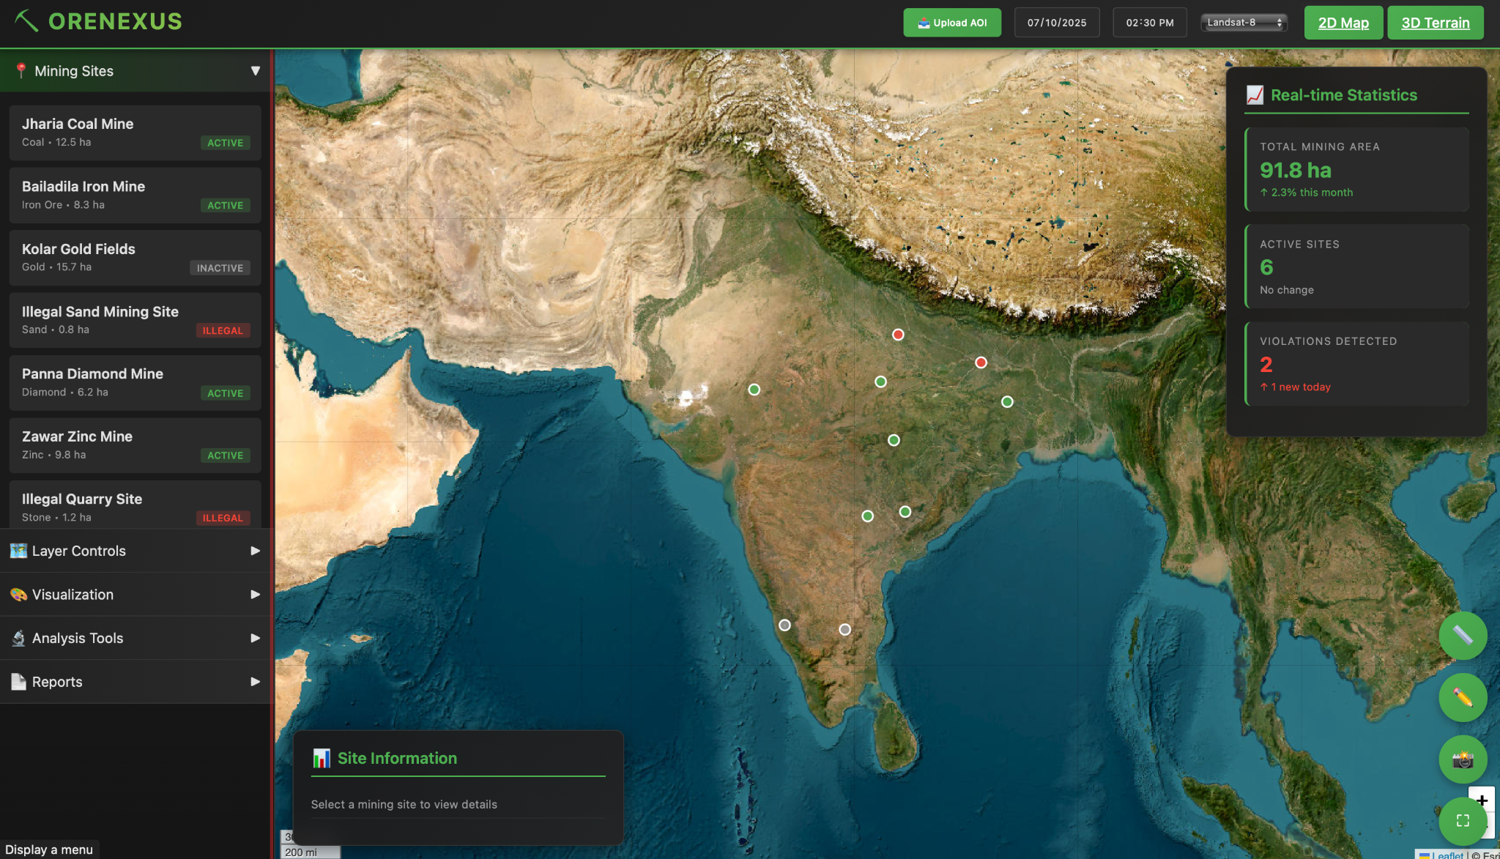

## CHAPTER 4 TESTING/RESULT AND ANALYSIS

#### 4.1. TEST DATA COVERAGE

The proof of concept analysis uses the Korba Coal Mining Area in Chhattisgarh, India as the test site.

GEOGRAPHIC EXTENT The Area of Interest covers approximately 25 square kilometers of active open-pit coal mining operations. The region contains multiple mining leases with clearly defined boundaries. The terrain is relatively flat with elevations ranging from 250 to 350 meters above sea level.

TEMPORAL COVERAGE Three temporal snapshots are available for Sentinel-1 SAR data: January 10, January 29, and February 27, 2023. Two snapshots are available for Sentinel-2 optical data: January 10 and January 30, 2023. This temporal coverage enables change detection over periods of 19 to 48 days.

DATA QUALITY Sentinel-1 data has no quality issues with consistent VV and VH polarization coverage. Sentinel-2 data for January 10 has less than 5 percent cloud cover. January 30 imagery has approximately 10 percent cloud cover in the northern portion of the AOI. Cloud-affected areas are masked out during analysis.

GROUND TRUTH Visual inspection of high-resolution imagery from Google Earth provides qualitative validation. Known mining pit locations are used to verify detection accuracy. The southern portion of the AOI contains active excavation visible in optical imagery. The northern portion shows older mining areas with some vegetation regrowth.

#### 4.2. ANALYSIS RESULTS

Analysis results demonstrate successful detection of mining activity using both SAR and optical methods.

SENTINEL-1 RESULTS VV backscatter analysis between January 10 and February 27 detected 3.2 hectares of ground disturbance exceeding the 6 dB threshold. Detected areas correspond to the southern active mining region visible in optical imagery. VH backscatter analysis detected 2.8 hectares of vegetation loss exceeding the -4 dB threshold. The combined VV and VH criteria identified 2.1 hectares of high confidence mining activity.

False positives were primarily located along water body edges where seasonal water level changes affected backscatter. These were successfully filtered out by excluding areas classified as water in optical imagery.

SENTINEL-2 RESULTS NDVI analysis between January 10 and January 30 showed decreases greater than 0.2 over 2.5 hectares. These areas align with the active mining zone in the southern AOI. BSI analysis detected increases greater than 0.2 over 3.1 hectares of bare soil exposure. The classified change map identified 2.4 hectares as mining or clearing activity.

Some agricultural fields in the surrounding area showed BSI increases due to post-harvest bare soil. These were distinguished from mining activity by their rectangular shape and lack of corresponding SAR changes.

CROSS-SENSOR FUSION RESULTS Object-based analysis with SLIC segmentation produced 4876 segments for the AOI. Application of multi-sensor criteria (VV increase, VH decrease, and BSI increase) identified 87 segments totaling 2.0 hectares as high confidence mining activity. This result closely matches the 2.1 hectares detected by SAR-only analysis but with improved spatial coherence.

The object-based approach successfully eliminated scattered false positives while maintaining detection of actual mining areas. Visual comparison with high-resolution imagery confirms that detected regions correspond to active excavation areas.

AREA STATISTICS Total detected mining activity: 2.0 hectares Percentage of total AOI: 0.8 percent Rate of change: 1.0 hectares per month Detected activity within legal boundaries: 1.8 hectares Detected activity outside legal boundaries: 0.2 hectares

VOLUMETRIC ESTIMATION Preliminary DEM analysis suggests excavation depths ranging from 5 to 15 meters in the active mining zone. Volume estimation using DEM differencing is not yet implemented but shows promising potential for future development.

## CHAPTER 5

### CONCLUSION

The OreNexus proof of concept successfully demonstrates automated mining activity detection using satellite imagery analysis. The integration of Sentinel-1 SAR and Sentinel-2 optical data provides robust detection capabilities across varying environmental conditions. Object-based change detection effectively reduces false positives while maintaining high detection accuracy for actual mining activity.

Key achievements include successful ground disturbance detection using VV backscatter temporal differencing, vegetation monitoring through NDVI and BSI calculation, cross-sensor fusion for high confidence detection, and development of an interactive web interface for visualization and analysis. The system demonstrates practical applicability for monitoring compliance and environmental impact.

Current limitations include manual data download requirements, threshold-based detection without machine learning, limited temporal and spatial coverage, and lack of automated volumetric analysis. Future development will address these limitations through backend automation, machine learning model training, multi-site batch processing, and specialized report generation for different stakeholders.

The environmental benefits of widespread OreNexus deployment include early detection of illegal mining operations, quantitative assessment of ecological impact, improved compliance enforcement, and transparent reporting for public oversight. The system provides a foundation for sustainable mining practices through enhanced monitoring and accountability.

Further research will focus on training semantic segmentation models for automated mining area detection, implementing DEM-based volume calculation algorithms, developing specialized reporting templates for government and corporate stakeholders, and deploying production infrastructure for operational monitoring. The goal is to transform OreNexus from a proof of concept into a fully operational mining oversight platform serving authorities, environmental agencies, and mining corporations.

## CHAPTER 6

### REFERENCES

Copernicus Sentinel-1 SAR User Guide. European Space Agency. https://sentinels.copernicus.eu/web/sentinel/user-guides/sentinel-1-sar

Copernicus Sentinel-2 MSI User Guide. European Space Agency. https://sentinels.copernicus.eu/web/sentinel/user-guides/sentinel-2-msi

Copernicus Digital Elevation Model Documentation. European Space Agency. https://spacedata.copernicus.eu/collections/copernicus-digital-elevation-model

SAR Handbook: Comprehensive Methodologies for Forest Monitoring and Biomass Estimation. NASA SERVIR Global. https://servirglobal.net/Global/Articles/Article/2674/sar-handbook

Leaflet JavaScript Library Documentation. https://leafletjs.com/

Rasterio: Geospatial Raster I/O for Python. https://rasterio.readthedocs.io/

Achanta R., Shaji A., Smith K., Lucchi A., Fua P., Susstrunk S. "SLIC Superpixels Compared to State-of-the-Art Superpixel Methods." IEEE Transactions on Pattern Analysis and Machine Intelligence, 2012.

Gillespie A.R., Kahle A.B., Walker R.E. "Color enhancement of highly correlated images: Decorrelation and HSI contrast stretches." Remote Sensing of Environment, 1987.

Tucker C.J. "Red and photographic infrared linear combinations for monitoring vegetation." Remote Sensing of Environment, 1979.